Product Demonstration

country club facilities booking system

table of contents
- Main Menu
- Member Manual
  - Member Login
  - Member Menu
  - Member Profile Subsystem
  - Edit Member Information
  - Member View Booking
  - Member View Discount Entitlement
  - Search Facilities Subsystem
  - Member Book Facility
- Manager Manual
  - Manager Login
  - Manager Menu
  - Manager Add Facility
  - Manager Search Facility
  - Manager Delete Facility
  - Manager Update Facility
  - Manager Process a Book
  - Manager Query Member Info
  - Manager Update Member Ranking
  - Manager Monthly Report
  - Manager Recent Report
- Admin Manual
  - Admin Login
  - Admin Menu
  - Admin Add A Member
  - Admin Search A Member
  - Admin Update Member Info
  - Admin Delete A Member
  - Admin Add Manager
  - Admin Search Manager
  - Admin Delete Manager
  - Admin Monthly Report
  - Admin Recent Report

Main Menu
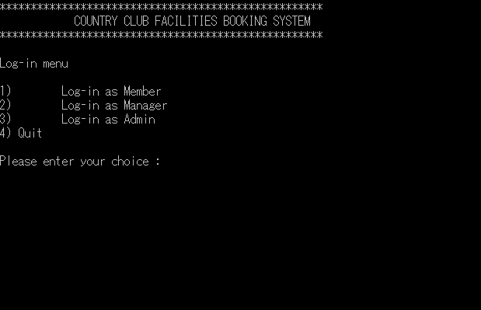
User need to login, depending on who they are.

Member manual

Member login
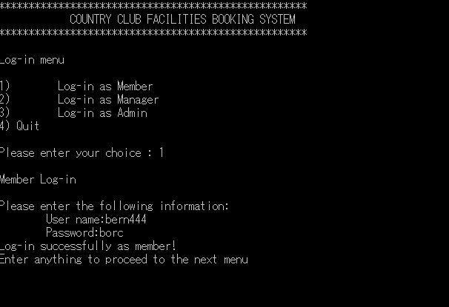
To login as member, member need to choose option 1.
Member need to enter their Username and Password to login.
For this demonstration, we use a demo account, with username bern444 and borc as the password.

member menu
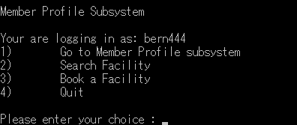
This is the system menu for member.
Member can choose to go to the profile, search facility, book a facility, and quit the system.

member profile subsystem
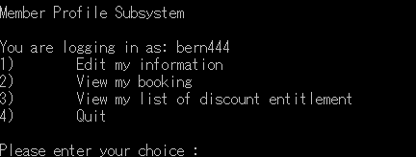
On the profile subsystem, member can edit their information, view their booking list, view their list of discount, and quit the profile subsystem.

edit member information
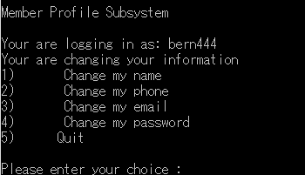
Member can edit their name, phone, email, and password.
Any change happen here, will be updated on the database.


Edit name.


Edit phone.


Edit email.


Edit password.

member view booking
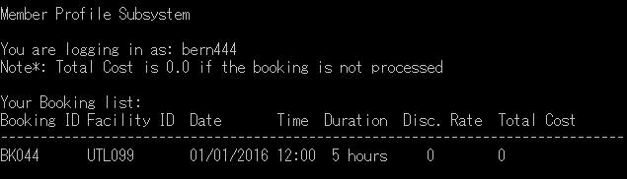
Member view all of the booking made by them.

member view discount entitlement

Member view all of the discount given to them.

search facilities subsystem
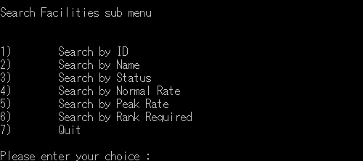
Member can search facilities by ID, name, status, normal rate, peak rate, and rank required.

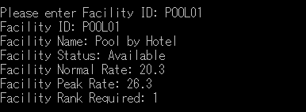
Search by ID. Member enter the facilities ID.

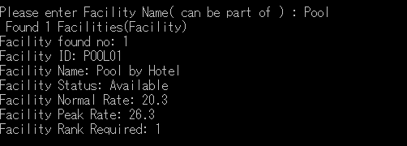
Search by name. Member enter the facilities name.

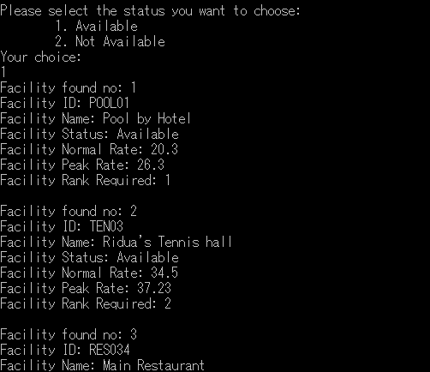
Search by status will show a list of the facilities, depending on the status.
Member need to choose available or not available.

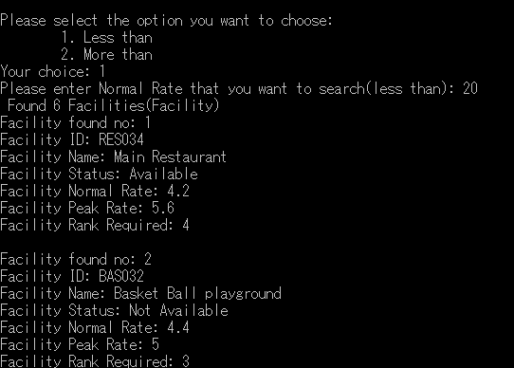
Search by normal rate will show a list of facilities, by the normal rate member wish to see. Member can choose to search by less than or more than, then input the normal rate.

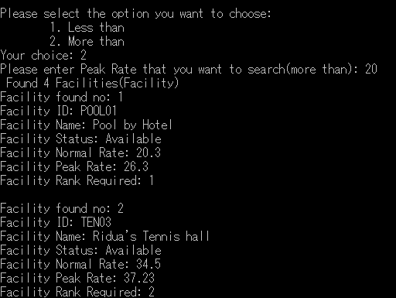
Search by peak rate will show a list of facilities, by the peak rate member wish to see. Member can choose to search by less than or more than, then input the peak rate.

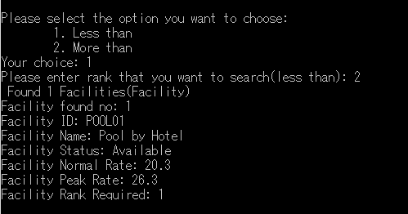
Search by rank required will show a list of facilities, by the required rank. Member can choose to search by less than or more than, then input the rank.

MEMBER book facility
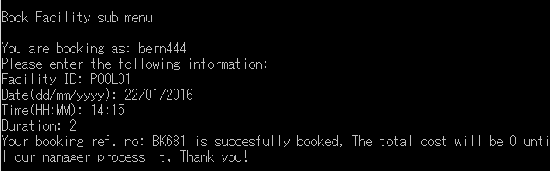
When booking a facility, member need to enter the facility ID, date they want to book, the time, and the duration (in hours).
Then, the booking will be processed by manager.

Manager manual

manager login
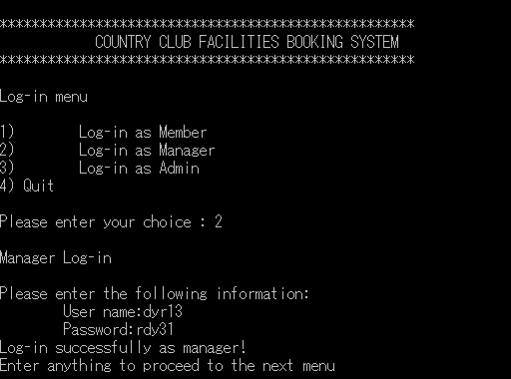
To login as manager, manager need to choose option 2.
Manager use their username and password to login.
For this demo, we will use username “dyr13” and password “rdy31” to login.

manager menu
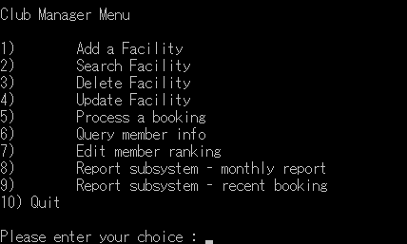
This is the manager menu.
Manager can add facility, search facility (same with member), delete facility, update facility, process a booking, query member info, edit member rank, and check the report summary by month and recent.

manager add facility
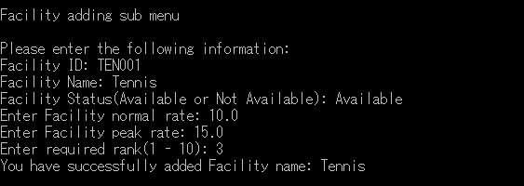
To add a facility, manager need to enter the facility ID, facility name, status, normal rate, peak rate, and the minimum rank.

manager search facility
Since manager are member, and the search function is same, please refer to the member search facility page

manager delete facility
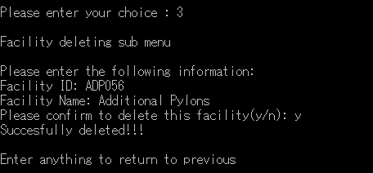
To delete a facility, manager need to enter the facility ID, then the system will show the facility name, and confirm the deletion with manager.

manager update facility
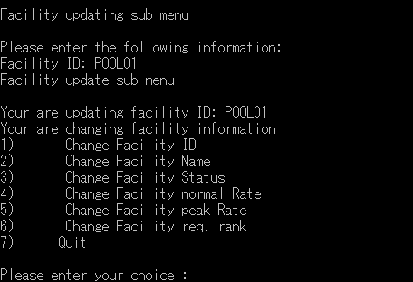
To enter the update facility menu, manager need to enter the facility ID, then the system will show the update facility menu, where manager can choose to update what they wish.


To update the facility ID, manager need to enter the new facility ID

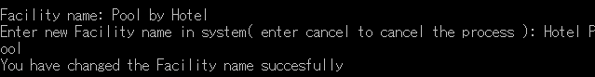
To update the facility name, manager need to enter the new facility name.


To update the facility status, manager need to enter the new facility status.

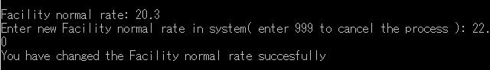
To update facility normal rate, manager need to enter the new facility normal rate.

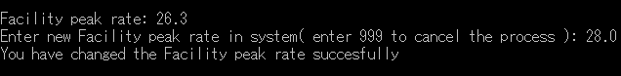
To update facility peak rate, manager need to enter the new facility peak rate.


To update the required rank, mananger need to enter the new required rank (1 – 10).

manager process a book

Manager need to enter the booking reference ID, if it is valid, then the system will show the process book menu, where manager can deny or process the booking.


If the manager decide to deny the booking, it will be deleted from the system.

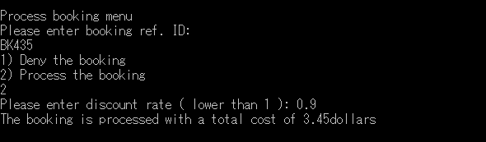
If manager decide to process the booking, it will be processed with the rate times the discount rate, and updated on the database

manager Query member info

To query member’s information, manager need to input the member ID. Then the system found the member, system will show the member’s name, email, phone, and rank.

MANAGER update member ranking

To update member’s rank, manager need to enter the member ID. If found, system will display the member’s current rank, then prompt user to enter the new rank (1 – 10).

manager monthly report
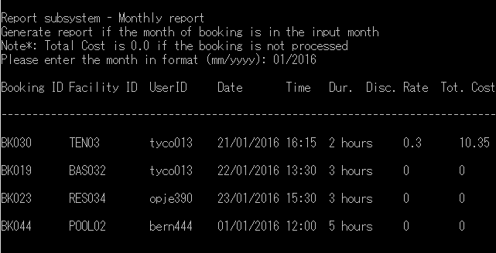
To view the monthly report, manager need to input the month manager want to see.
If there is any booked facility on that month, the system will show the list.
The total cost and discount rate will be 0, if the manager have not processed the booking.

manager recent report
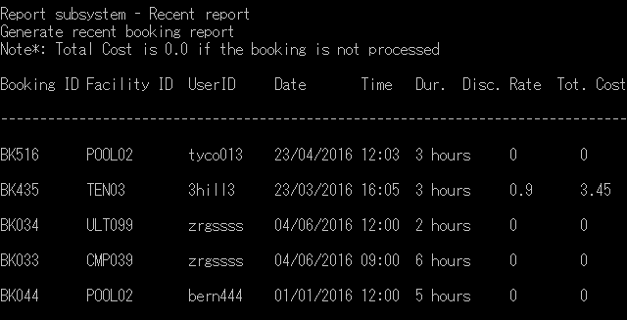
If manager decided to view the recent report, system will show the latest 5 book made by the user.
The total cost and discount rate will be 0, if the manager have not processed the booking.

admin manual

admin login
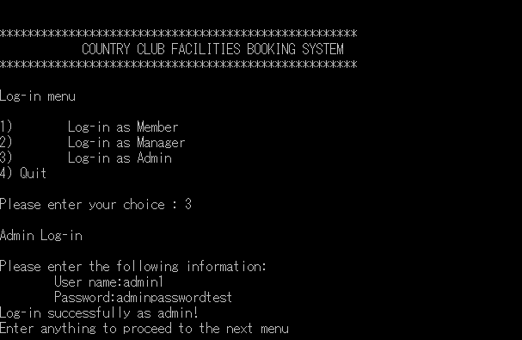
To login as admin, admin need to choose option 3.
Then admin will be prompted to enter the username and password.
For this demo, we will use “admin1” as username, and “adminpasswordtest” as password.

ADMIN MENU
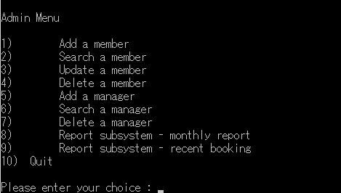
When an admin successfully login to the system, the menu will be shown for them.
Admin can add a member, search a member, update a member, delete a member, add a manager, search a manager, delete a manager, and monthly or recent book report (same with manager).

admin add a member

To add a member, admin need to input the member ID, password, name, email, phone, and rank.

admin search a member

To search a member, admin need to input the member ID.
If member found, system will show the member’s name, email, phone, and rank.

admin update member info
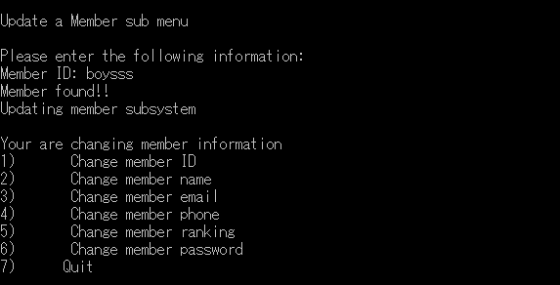
To update member’s info, admin need to input the member ID. If found, system will show the member update menu.


To update member’s ID, admin need to input the new member ID.


To update member’s name, admin need to input the new member name.


To update member’s email, admin need to input the new member email.

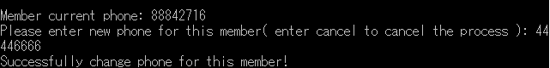
To update member’s phone number, admin need to input the new member phone number.


To update member’s rank, admin need to input the new member rank.


To update member’s password, admin need to input the new member password.

admin delete a member

To delete a member, admin need to input the member’s ID.
If member is found, the system will show the member’s name, and ask admin for confirmation.

admin add manager
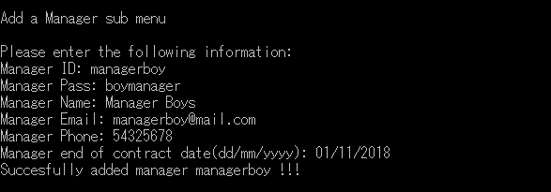
To add a manager, admin need to input the manager ID, password, manager name, email, phone, and the end of contract date.

admin search manager

To search a manager, admin need to input the manager ID.
If the manager is found, system will show the manager name, email, phone, and end of contract.

admin delete a manager
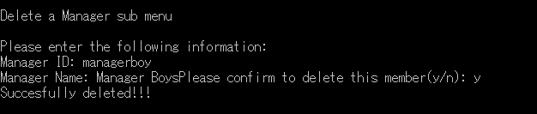
To delete a manager, admin need to enter the manager ID.
If the manager is found, system will ask admin for delete confirmation.

admin monthly report
Since manager and admin’s monthly report are same, please refer to the manager monthly report.

admin recent report
Since manager and admin’s recent report are same, please refer to the manager recent report.

